
Rocks N' Pebbles from Munich ( D )

American – British Rock & Blues

Available for events in & around Munich, Upper Bavaria, Austria & Spain from September 2024
-----------------------------------------------------------------------------------------
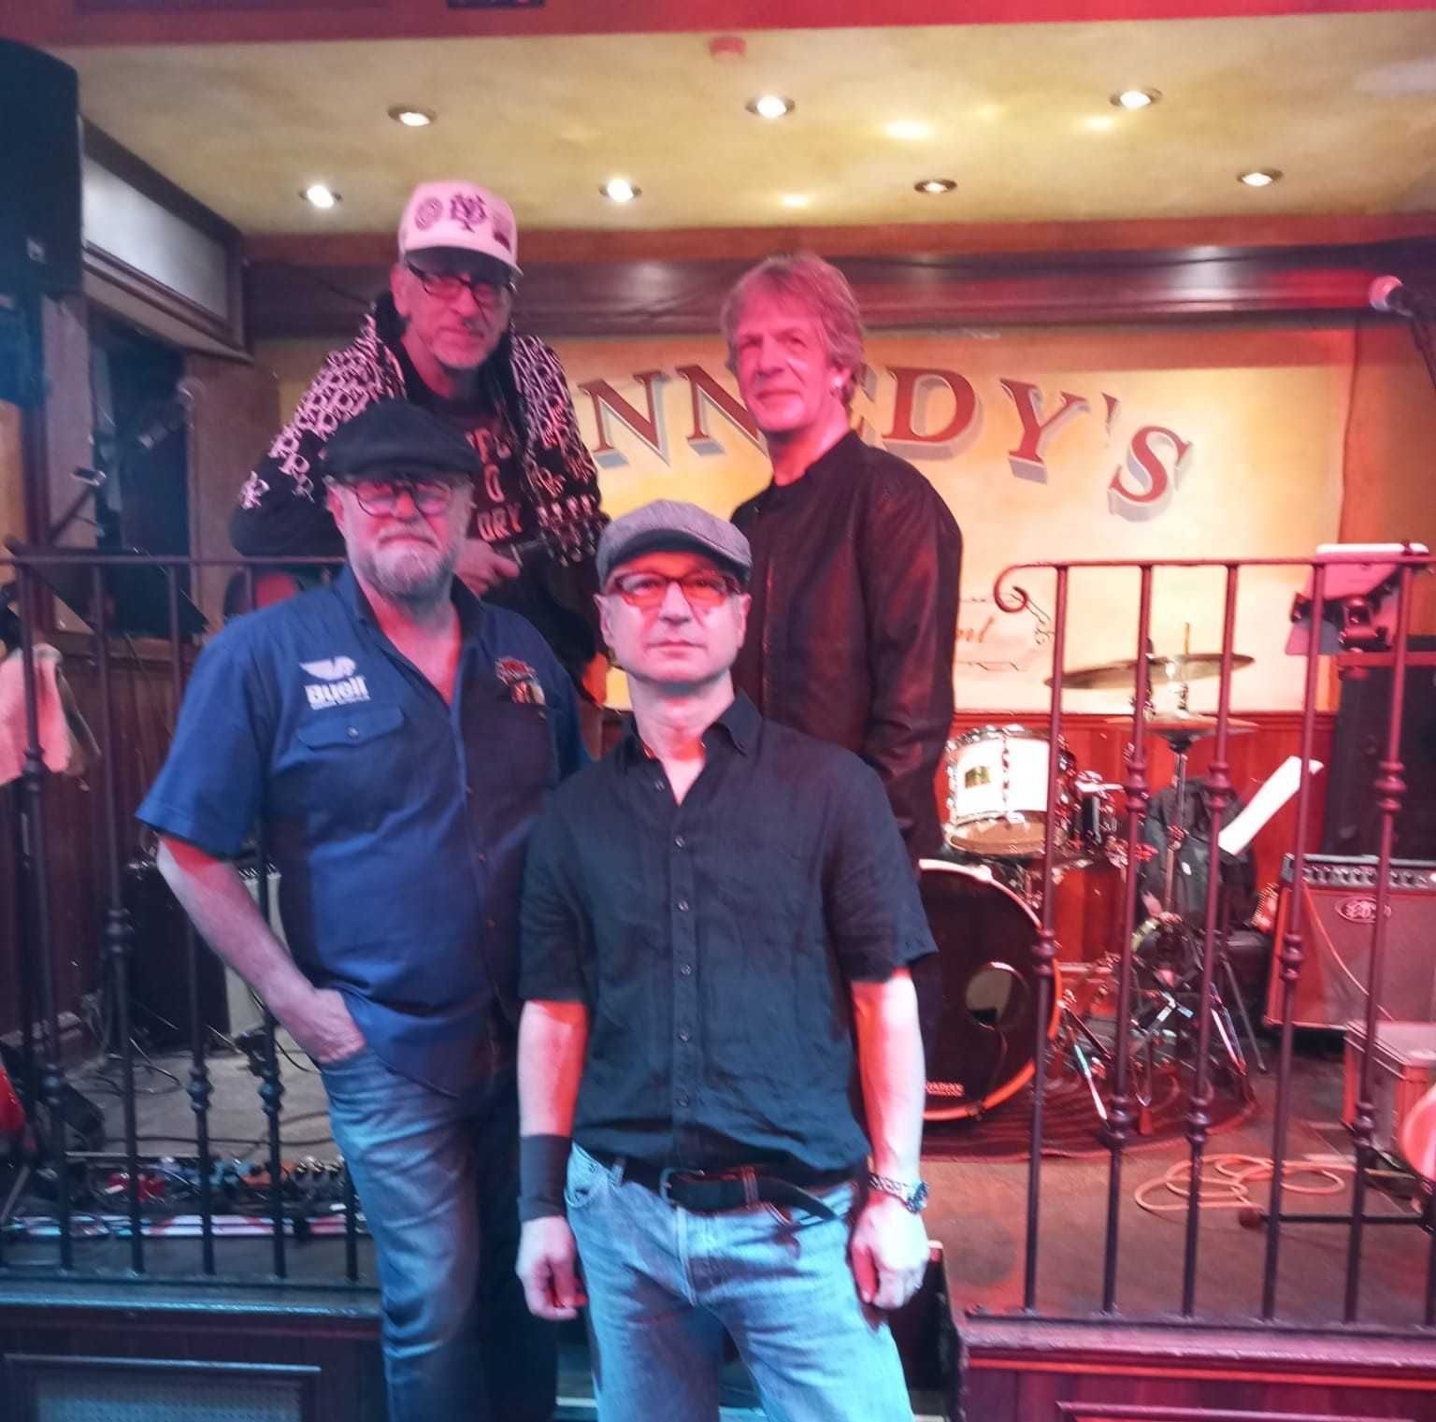
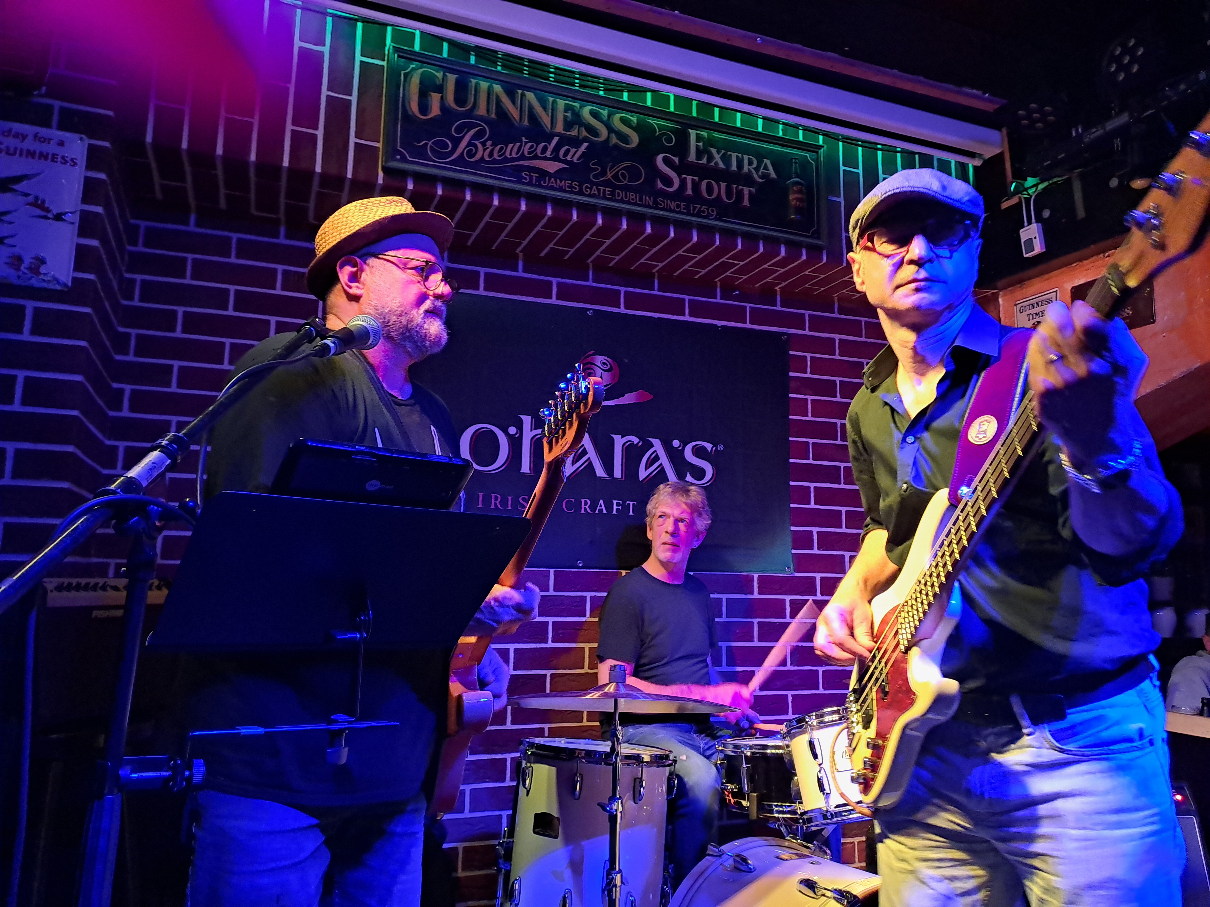

PRACTICAL:

Tour period: from September 2024
Crew: 3 – 5
Backline: available if necessary
Rider: see page 2 / enclosed

INFO:

Watch & listen: RocksNPebbles - YouTube
Website: Startseite (rocksnpebbles.de)

About Rocks N' Pebbles:
Rocks N' Pebbles was founded nearly 30 years ago.
Five friends from and around Munich will deliver (professional plugged & unplugged) Rock & Blues Charthits from Nord- / Middleamerica & the British islands to the best.

3 regular musicians (as a trio) and 2 guest musicians play nationally in/around Munich and internationally in Austria and Spain as required. We cover 70 well-known top chart rock & blues songs, in a variable, tastefully coordinated set list
References national:
Rockmuseum Olympiaturm Munich, Rock N' Race Bad Tölz, US Car meeting Bad Tölz, BMW Classic Munich, Knorr-Bremse Munich, Kilians & Kennedys Munich
References international:
Piratas Rock Madrid ( Spain ), Attersee ( Austria ), Reggae Open Air - Bloody Bay ( Jamaica ).
Rocks N' Pebbles is the perfect choice for fun on and off stage. We get the guests singing and dancing along. An all-round package for events with friends, families and companies.

Booking: rocksnpebbles@gmx.de / +49 179 6963979

Rocks N' Pebbles tecrider:

